Week of | 8/3/2015
Content Area | Social Studies
Course/Grade | 8th Grade Georgia Studies
Unit of Study | Concepts and Themes; Geography of Georgia
Instructional Focus | Students will be introduced to the concepts and themes of Social Studies; Students will also study and cover the Geography of Georgia.
Insert a standard(s) below (include code). HIGHLIGHT the SKILLS that students need to be able to do and UNDERLINE the CONCEPTS that students need to know (TKES 1,2)
Themes:

(Unit 1):

Week 1: Students will understand the following themes and concepts in Social Studies: CONFLICT AND CHANGE, DISTRIBUTION OF POWER, INDIVIDUALS, GROUPS, AND INSTITUTIONS, LOCATION, MOVEMENT/ MIGRATION, POWER, AUTHORITY, AND GOVERNANCE, PRODUCTION, DISTRIBUTION, AND CONSUMPTION, RULE OF LAW, TECHNOLOGICAL INNOVATION.

(Unit 2)

Week 2: Standards: SS8G1 Describe Georgia with regard to physical features and location.
  - Locate Georgia in relation to region, nation, continent, and hemispheres.
  - Describe the five geographic regions of Georgia; include the Blue Ridge Mountains, Valley and Ridge, Appalachian Plateau, Piedmont, and Coastal Plain.
  - Locate and evaluate the importance of key physical features on the development of Georgia; include the Fall Line, Okefenokee Swamp, Appalachian Mountains, Chattahoochee and Savannah Rivers, and barrier islands.
  - Evaluate the impact of climate on Georgia's development.

Pre-assessment to Inform Instruction
(TKES 5,6):

Unit 1: Introduction to Themes and Concepts: Students will be asked the following questions about the themes:
From your previous Social Studies courses, what possible Enduring Understandings do you remember?

Basic Globe and Map Skills: Brain Pop (Basic Map and Globe Skills)
Define Hemisphere, Continent, Nation, Region, Global, boundaries, physical and political features, development, climate.

Students given blank Georgia Map to identify the five regions: Blue Ridge Mountains, Valley and Ridge, Appalachian Plateau, Piedmont, and Coastal Plain. (page 157 in Coach book)

Unit 2: Students will utilize maps of Georgia in the Atlas and review book and discuss the following questions:
- Where is Georgia in terms of hemisphere, continent, nation, region and global position? (G1a)
- Which North American physiographic regions are found in Georgia and what are some distinguishing characteristics of each? (G1b)
- What is the relative location of these physiographic regions within the boundaries of the State? (G1b)
- What are the significant physical features of Georgia that have impacted its development and in what manner have the affected Georgia? (G1c)
- How has climate played a role in Georgia’s development? (G1d)

- How have waterways influenced Georgia’s exploration, settlement, and economic development?
- How do the Interstate Highway System, Hartsfield-Jackson International Airport, the railroad system and Georgia’s deep-water ports drive the state’s economy?
- How do the four transportation systems relate in their transportation of good through the state, nationally and internationally?
- How do Georgia’s three major transportation systems interact to provide domestic and international goods and services to Georgia’s consumers?

- Students will review Unit One info on Monday
- Unit 2 will be Tu/Th and W/F
Assessment for Learning or Assessment of Learning (Post-assessment)
(TKES 5,6)

Students will be given ticket out of the door or mini-quiz based on standard and content learned from the information.

Differentiated Instruction
(TKES 4,8)
The following strategies will be used throughout the week for differentiated instruction:

- Fist of Five—Each finger represents how well information is known. The scale goes from a beginner to a knowledgeable student that is able to explain.
- Face the Fact—Students use happy, straight or sad faces to respond to teacher information. The face reflects the emotion of the student as the teacher is teaching. This allows the teacher to obtain immediate feedback as to how students feel about the information that is being taught.
- Talking Topic—Assign students partners. Each partner tells a fact to the other partner. They continue to keep swapping facts back and forth.
- Conversation Circles—Form a conversation circle with three students. A begins talking about topic. B then continues with topic and C picks up the topic after B. This is continued until there are no more facts or ideas to add to the topic.
- Yes /No Cards—Students make each set of cards. They write YES on one and NO on the other. They may use the back and front of one piece of paper, or they may have a piece of paper for each word. The teacher can ask a yes or no question and easily gage the knowledge of the students.
- Graffiti Fact—Create a graffiti board of facts. Post all things the class knows about the topic of study. They can respond to what they know, what they learned, or what they want to learn next. Allow processing time for students to answer the question. Allow students time to write their own responses to be posted since this creates ownership.
- Groups: In addition, groups will be created based on assessment and pre assessment results. As a result, students who are accelerated are given an assignment accordingly; as well as middle and lower-level students. The teacher will work/instruct students that need that extra support.

Data Used | Data Findings | Interventions |  | Enrichments |  | Grouping Decisions | Strategies Used | Instructional Time Needed |  | Predicted Outcome
Pre-assessment information from the Essential Questions and Opening Questions; These will determine the groups and level of instruction. | Due to this being the first week of school, there are no prior data findings. We will be utilizing the opening portion of the lesson to determine areas of concern. | Map Skills; Globe Skills; introducing the skills needed to interpret the maps/atlases to gain information |  | Students can create virtual maps/outlines of Georgia’s regions, key physical features and climate maps using home products/items to present to the class. |  | After themes and regions are discussed; students can choose which groups they would prefer in order to learn more about Georgia’s regions. Afterwards, based on understanding, students will be grouped for remediation and enrichment. | Grouping,  Yes, No Cards  Partnering  Conversation Circles, Graffiti Facts  Face the Fact  Fist of Five | 15-intro  15 lesson  20 activity  15 lesson part 2  20 activity  5 closing |  | It is believed the data will demonstrate student growth and efficiency. Students will have an understanding about the themes of SS and the Geographical Regions, key physical features and climate.
(add commentary here) | (add commentary here) | (add commentary here) |  | (add commentary here) |  | (add commentary here) | (add commentary here) | (add commentary here) |  | (add commentary here)
WHY?  If modification is needed, it will be due to the following: |  |  | Check all that apply for the current week of lessons:  X access to learning  X motivation to learn  X efficiency of learning |  |  |  | Explanation of learning experience modifications:  There are various learning styles within these courses. It is possible that for some activities, I will need to ensure students complete tasks that are motivational, efficient and accessible. I do plan on implementing a flip lesson; however, for students that do not have internet access, they will be able to go to the media center for needed materials.
HOW?  If modification is needed, it will be based on the following: |  |  | Student Trait(s):  X readiness (needs prerequisite, ready, advanced)  X interest (data should be gathered and disaggregated)  X learning profile (predetermined by students’ ILPs) |  |  |  | Specific response to student trait:  Students will be given introductory questions that will determine where they are based on their answers. If their readiness permits them to move to the next level, they should. As far as interest, there will be grouping based on the interest, including choice tasks.
WHAT?  The content, process, product and learning environment is based on the following: |  |  | CONTENT  - Students will learn the following: SS Themes and Concepts  - Georgia’s physical features and location |  | PROCESS  Students will learn the content through differentiated questioning, instruction, activities and closings |  | PRODUCT  - Students will create group examples and presentations based on 2 out of the themes.  - Afterwards, students will write a quick summary of the themes and how they apply to social studies. Students will also receive a handout.  - Students will receive a blank map and are asked to identify the 5 regions and key physical features. This will go into interactive notebook.  - Students will take the same map and use tools (beans for mountains; chalk and glue for swamp; noodles for the fall line; markers for the islands).  - Students will create a Georgia Climate Map |  | LEARNING ENVIRONENT  (TKES 7)  Positive learning environment  Collaboration  Assessment  Teacher-assisted (and lead) instruction
List Behaviors  (what students should be able to do; focus on verbs)  (TKES 2,8) |  |  |  |  |  |  | List Content  (what students should know; focus on concepts)  (TKES 2,8)
Week 1: Students will understand the following themes and concepts in Social Studies: CONFLICT AND CHANGE, DISTRIBUTION OF POWER, INDIVIDUALS, GROUPS, AND INSTITUTIONS, LOCATION, MOVEMENT/ MIGRATION, POWER, AUTHORITY, AND GOVERNANCE, PRODUCTION, DISTRIBUTION, AND CONSUMPTION, RULE OF LAW, TECHNOLOGICAL INNOVATION.  (Unit 2)  Week 2: Standards: SS8G1 Describe Georgia with regard to physical features and location.  - Locate Georgia in relation to region, nation, continent, and hemispheres.  - Describe the five geographic regions of Georgia; include the Blue Ridge Mountains, Valley and Ridge, Appalachian Plateau, Piedmont, and Coastal Plain.  - Locate and evaluate the importance of key physical features on the development of Georgia; include the Fall Line, Okefenokee Swamp, Appalachian Mountains, Chattahoochee and Savannah Rivers, and barrier islands.  - Evaluate the impact of climate on Georgia's development. |  |  |  |  |  |  | At the end of the week, students should know:  - The themes and concepts in SS  - Georgia’s important physical features and development  At the end of the unit, students should know:  - How to locate Georgia in relation to region, nation, continent and hemisphere  - 5 geographic regions  - Importance of key physical features: fall line, okefenokee swamp, Appalachian mountains, Chattahoochee and savannah rivers, barrier islands  - Georgia’s climate and how it impacts development
Vocabulary Tiers
Students will be introduced to the vocabulary through instruction (direct) as well as through collaborating with peers. The following vocabulary will be obtained through this unit, along with an explanation of the lessons to demonstrate mastery.
Vocabulary- Tier 1  (What is the basic, everyday vocabulary that students should already know? Non content-specific) | Vocabulary Tier 2  (What vocabulary will be taught during the lesson/unit that students will most likely encounter in other contents?) | Vocabulary Tier 3  (What content/domain-specific vocabulary will students engage with during the lesson/unit?)
- Map  - Location  - Physical  - Political  - Region  - Continent  - Relative (location)  - Absolute (location)  - Climate  - Weather  - Longitude  - Latitude  - Meridians  - Prime meridian  - Hemisphere  - Equator  - drought | - Conflict  - Change  - Distribution of power  - Governance  - Individuals  - Groups  - Institutions  - Location  - Movement  - Migration  - Production  - Distribution  - Consumption  - Rule of law  - Technological innovation | - Geography  - continent  - Appalachian Mountains  - Appalachian Plateau  - Ridge and Valley  - Blue Ridge Mountains  - Piedmont Plateau  - Coastal Plain  - Fall Line  - Wetland  - barrier islands  - Okefenokee Swamp  - Atlantic Intracoastal  - Savannah River  - Chattahoochee River  - Deepwater ports  - Interstate  - State route  - Highway  - Hartsfield-Jackson International Airport  - Interstate Highway System  - Railroads
Vocabulary Instruction
(TKES 2,3,8)
Students will be asked to define the basic, everyday vocabulary (Tier 1) (if time permits, students will be assigned 3-4 words by teams). Afterwards, students will present vocabulary to class. Student work will be exhibited on walls.

Students will also be given the definition and lesson to the Tier 2 words. Students will group off and come up with examples of the following words. They will either present a graphic organizer, story, poem or skit based on their choices of 4-5 words.

For Tier 3 words, students will be given the assignments that will allow hands-on implementation of the words. Students will also create a (or PowerPoint point/Prezi) presentation of Georgia, its geography, physical features and climate. As a result, they will use these words to express learning.
Daily Instruction
(TKES 1-10)
Monday: 8/3/2015
Instructional Focus: Teaching the Themes
Instructional Format: Instructional formats include collaborative groups, individual work, teacher-guided instruction
Instructional Strategies  □ Identifying similarities and differences  □ Summarizing and note taking  □ Reinforcing effort and providing recognition  □ Homework and practice  □ Nonlinguistic representations  □ Cooperative learning  □ Setting objectives and providing feedback  □ Generating and testing hypothesis  □ Questions, cues, and advance organizers  □ Goal setting  □ Visible Learning  □ Chunking  □ Guided Reading  □ NAL  □ Scaffolding  □ Graduated Difficulty  □ Reciprocal Teaching  □ Other ____________________________________  □ Other ____________________________________ | Webb’s Depth of Knowledge  Students will complete a map skills review in groups and individually.  Students will construct a model of the state of Georgia that includes the 5 regions and physical features.  □ Level 2: Map skills and geographic regions review  □ Level 3: Graphic organizer introduction and review; analyzing the themes and concepts.  □ Level 4: Students will construct a model of the state of Georgia that includes the 5 regions and physical features. | COSTA’s Levels of Questioning  □ Level 1: What are the 5 geographic regions of Georgia?  □ Level 2: Where is Georgia in terms of hemisphere, continent, nation, region and global position?  □ Level 3: How do Georgia’s three major transportation systems interact to provide domestic and international goods and services to Georgia’s consumers?
WICOR  (All WICOR components should be represented each week. You have the autonomy to choose when and how; however, it is important that multiple AVID strategies can be experienced in all courses)  □ WRITING: Reflection on how the themes are related to Georgia.  □ INQUIRY: Students will answer the essential questions related to the information.  □ COLLABORATION: Students will work collaboratively with others to construct a replica of Georgia.  □ ORGANIZATION: Students will begin Cornell notes on the themes and geography of Georgia. They will also utilize their table of contents for organization.  □ READING: Students will use atlases and maps for critical thinking that includes the absolute and relative location of Georgia. | Primary Instructional Strategy  Summarizing and note taking  Cooperative learning  Setting objectives and providing feedback  Guided Reading | Primary Instructional Activity  Group Diorama Activity: Constructing a replica of the state of Georgia including:  - 5 regions  - major physical features  - climate  - (relative and absolute) location of Georgia  - How they all contribute to the economy
OPENING: EXPLANATION
(5 minutes)

Good Morning and introductions
*icebreaker

Students will be introduced to one another

TRANSITION FROM OPENING TO WORK PERIOD

Students will transition to expectations, procedures and consequences (an overview of the day)
WORK PERIOD: APPLICATION
(30 minutes)
Expectations
Procedures
Consequences
Tardy Policy
Group Etiquette
Technology Expectation
National History Day
Students will then reflect on their expectation of the class, teacher and themselves
*if time permits, overview of Map Skills

(add commentary here)

TRANSITION FROM WORK PERIOD TO CLOSING

Student reflections of class expectations
CLOSING: SYNTHESIS
(10 minutes)
Students will have the opportunity the reflect on their expectations with their peers and with teacher
TRANSITION FROM CLOSING TO DLIQ
Do
Learn
Interesting
Question
Students will reflect on the information of the day and will discuss as a class.

DLIQ
(5 minutes)

Students will have a DLIQ section in their notebook after each lesson to reflect on what they have learned for the day.
Tuesday/Wednesday: 8/4-8/5
Instructional Focus: (What is the primary instructional focus for the day?) (add commentary here)
Instructional Format: (How will you provide instruction for each group of students—needs perquisite, ready, advanced—to move them to their next level of learning?)
(add commentary here)
Instructional Strategies  (at least three strategies should be clearly present in weekly lesson plans)  X Identifying similarities and differences  X Summarizing and note taking  X Reinforcing effort and providing recognition  X Homework and practice  Nonlinguistic representations  □ Cooperative learning  □ Setting objectives and providing feedback  □ Generating and testing hypothesis  □ Questions, cues, and advance organizers  □ Goal setting  □ Visible Learning  □ Chunking  □ Guided Reading  □ NAL  □ Scaffolding  □ Graduated Difficulty  □ Reciprocal Teaching  □ Other ____________________________________  □ Other ____________________________________ | Webb’s Depth of Knowledge  (Webb’s Depth of Knowledge classifies tasks according to the complexity of thinking needed to complete the tasks. Specifically explain what students will do; i.e., students will CONSTRUCT an exact replica of a standard telescope)  □ Level 2: Map skills and geographic regions review  □ Level 3: Graphic organizer introduction and review; analyzing the themes and concepts.  □ Level 4: Students will construct a model of the state of Georgia that includes the 5 regions and physical features. | COSTA’s Levels of Questioning  (COSTA’s Levels of Questioning helps students develop higher levels of thinking and questioning. Specifically describe the scaffolding of questioning that will take place during the lesson/unit. For example, students will be required judge the validity of a character’s motive. Sample question: Was Mr. Wilson justified when he sought to kill Gatsby?—level 3 questioning)  □ Level 1: What are the 5 geographic regions of Georgia?  □ Level 2: Where is Georgia in terms of hemisphere, continent, nation, region and global position?  □ Level 3: How do Georgia’s three major transportation systems interact to provide domestic and international goods and services to Georgia’s consumers?
WICOR  □ WRITING: Reflection on how the themes are related to Georgia.  □ INQUIRY: Students will answer the essential questions related to the information.  □ COLLABORATION: Students will work collaboratively with others to construct a replica of Georgia.  □ ORGANIZATION: Students will begin Cornell notes on the themes and geography of Georgia. They will also utilize their table of contents for organization.  □ READING: Students will use atlases and maps for critical thinking that includes the absolute and relative location of Georgia. | Primary Instructional Strategy  Summarizing and note taking  Cooperative learning  Setting objectives and providing feedback  Guided Reading | Primary Instructional Activity  (Group Diorama Activity: Constructing a replica of the state of Georgia including:  - 5 regions  - major physical features  - climate  - (relative and absolute) location of Georgia  - How they all contribute to the economy  - Attractions of their choice
C.L.E.A.R. (Literacy across Contents Initiative)
(20 minutes)
Social Studies introduction; map and magazine skills
Themes of Social Studies (8th grade GA history)
Georgia Physical Features information
Student SS Magazines to choose from and write a response
Students will be able to choose from these resources for reading

OPENING: EXPLANATION
(5 minutes)

Students will discuss map resources such as atlases; students will also review vocabulary for the introduction to GA students

Students will review basic map skills and how they relate to locating Georgia

TRANSITION FROM OPENING TO WORK PERIOD

Students will transition to reviewing the themes; gather notebooks and become ready for the day.
WORK PERIOD: APPLICATION
(30 minutes)
Notes;
2 Activities
2 lessons
Students will have an opportunity to review using notes and other resources such as Brain pop “what is a map”
Students will then reflect on the characteristics of a map

(add commentary here)

TRANSITION FROM WORK PERIOD TO CLOSING
Students will answer closing questions and are asked if there are in Questions, Comments and/or Concerns
CLOSING: SYNTHESIS
(10 minutes)
Students will have the opportunity the reflect on their expectations with their peers and with teacher
TRANSITION FROM CLOSING TO DLIQ
Do
Learn
Interesting
Question
Students will reflect on the information of the day and will discuss as a class.

Thursday/Friday: (DATES)
Instructional Focus: (What is the primary instructional focus for the day?) (add commentary here)
Instructional Format: (How will you provide instruction for each group of students—needs perquisite, ready, advanced—to move them to their next level of learning?)
(add commentary here)
Map skills and geographic regions review

Instructional Strategies  (at least three strategies should be clearly present in weekly lesson plans)  □ Identifying similarities and differences  □ Summarizing and note taking  □ Reinforcing effort and providing recognition  □ Homework and practice  □ Nonlinguistic representations  □ Cooperative learning  □ Setting objectives and providing feedback  □ Generating and testing hypothesis  □ Questions, cues, and advance organizers  □ Goal setting  □ Visible Learning  □ Chunking  □ Guided Reading  □ NAL  □ Scaffolding  □ Graduated Difficulty  □ Reciprocal Teaching  □ Other ____________________________________  □ Other ____________________________________ | Webb’s Depth of Knowledge  (Webb’s Depth of Knowledge classifies tasks according to the complexity of thinking needed to complete the tasks. Specifically explain what students will do; i.e., students will CONSTRUCT an exact replica of a standard telescope)  □ Level 2: Geographic regions and Physical features review  □ Level 3: Graphic organizer introduction and review; analyzing the themes and concepts.  □ Level 4: Students will construct a model of the state of Georgia that includes the 5 regions and physical features. | COSTA’s Levels of Questioning  (COSTA’s Levels of Questioning helps students develop higher levels of thinking and questioning. Specifically describe the scaffolding of questioning that will take place during the lesson/unit. For example, students will be required judge the validity of a character’s motive. Sample question: Was Mr. Wilson justified when he sought to kill Gatsby?—level 3 questioning)  □ Level 1: What are the 5 geographic regions of Georgia?  □ Level 2: Where is Georgia in terms of hemisphere, continent, nation, region and global position?  □ Level 3: How do Georgia’s three major transportation systems interact to provide domestic and international goods and services to Georgia’s consumers?
WICOR  (All WICOR components should be represented each week. You have the autonomy to choose when and how; however, it is important that multiple AVID strategies can be experienced in all courses)  □ WRITING: Reflection on how the themes are related to Georgia.  □ INQUIRY: Students will answer the essential questions related to the information.  □ COLLABORATION: Students will work collaboratively with others to construct a replica of Georgia.  □ ORGANIZATION: Students will begin Cornell notes on the themes and geography of Georgia. They will also utilize their table of contents for organization.  □ READING: Students will use atlases and maps for critical thinking that includes the absolute and relative location of Georgia. | Primary Instructional Strategy  (An instructional strategy is any approach you may take to actively engage students in learning. They drive instruction to meet specific learning objectives, all learning styles, and needs of the learners. A primary instructional strategy is the driving strategy for the week. This strategy begins the work that will be done within the lesson/unit and is most likely used a number of times. However, the primary instructional strategy should be paired with a number of supplemental strategies throughout the unit to render the most effective learning outcomes)  Summarizing and note taking  Cooperative learning  Setting objectives and providing feedback  Guided Reading | Primary Instructional Activity  (An instructional activity is a task that students will complete to demonstrate their understanding of the standards. Each instructional activity should be meaningful and should require high levels of thinking and performance. A primary instructional activity is considered the researched-based activity that introduces students to the standards, skills, and concepts of the lesson/unit)  (Group Diorama Activity: Constructing a replica of the state of Georgia including:  - 5 regions  - major physical features  - climate  - (relative and absolute) location of Georgia  - How they all contribute to the economy  - Attractions of their choice
C.L.E.A.R. (Literacy across Contents Initiative)
(20 minutes)

Read the standards in reference to the physical features of Georgia. Each student will write two facts about each feature and share with their neighbor.
(add commentary here)
TRANSITION FROM C.L.E.A.R. TO OPENING
(5 minutes)

Students will be asked if they have any questions and/or comments that they would like to share with the class.
OPENING: EXPLANATION
(30 minutes)
Students will view a PowerPoint about the physical features of Georgia. Students will do a think/pair/share after SS8G1.

(add commentary here)

TRANSITION FROM OPENING TO WORK PERIOD

Students will be asked to share their summary of the content.

WORK PERIOD: APPLICATION
(30 minutes)
Students will create (in a group) a large scale map of Georgia which will include the 5 regions and the physical features. Students will be allowed to use their technology devices to find other attractions in the state that they would like to add to their maps.
(add commentary here)

TRANSITION FROM WORK PERIOD TO CLOSING

Teacher will address all groups to ensure that the requirements of the assignment are being met.
CLOSING: SYNTHESIS
(30 minutes)

Students will create (in a group) a large scale map of Georgia which will include the 5 regions and the physical features. Students will be allowed to use their technology devices to find other attractions in the state that they would like to add to their maps.

(add commentary here)

TRANSITION FROM CLOSING TO DLIQ

Students will present their maps as a group to the class.
DLIQ

Students will explain what they did, learned, what they found interesting, and if they have any questions.
(add commentary here)

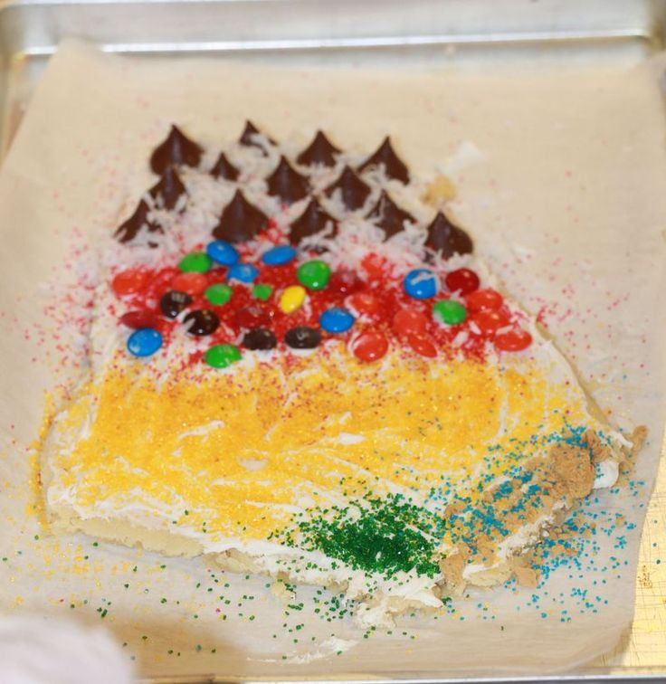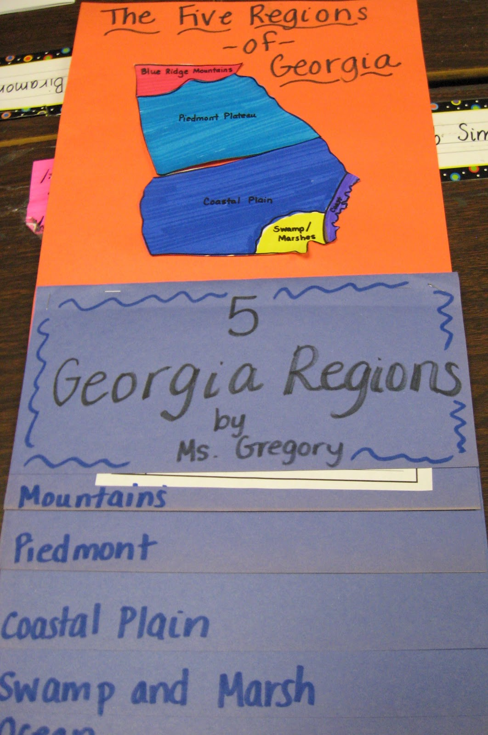https://www.pinterest.com/pin/164099980145353598/